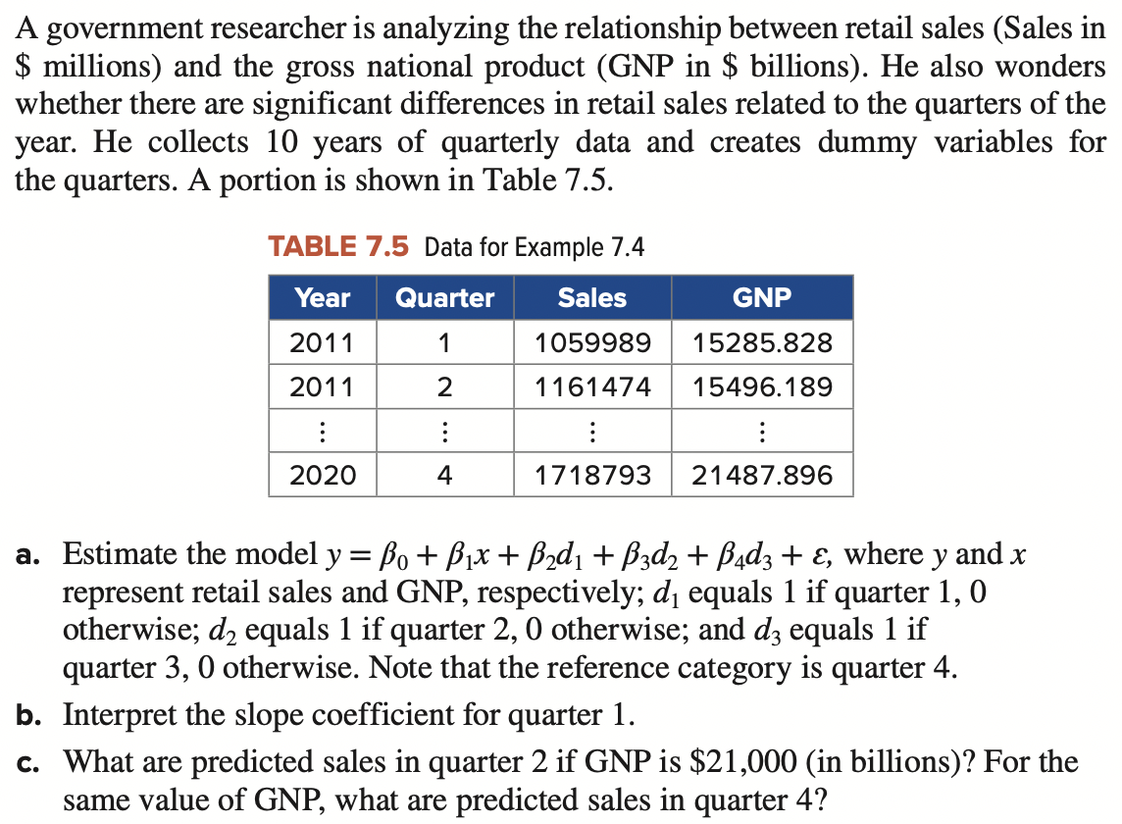
- Estimate the model where y and x represent retail sales and GNP, respectively; d1 equals 1 if quarter 1, 0 otherwise; d2 equals 1 if quarter 2, 0 otherwise; and d3 equals 1 if quarter 3, 0 otherwise. Note that the reference category is quarter 4.
- Interpret the slope coefficient for quarter 1.
- What are predicted sales in quarter 2 if GNP is $21,000 (in billions)? For the same value of GNP, what are predicted sales in quarter 4?
- Plot (1) the regressed value against the retail sales value and (2) residual, (3) do your think linear regression is fitted for this problem, why or why not?

